Answer 1
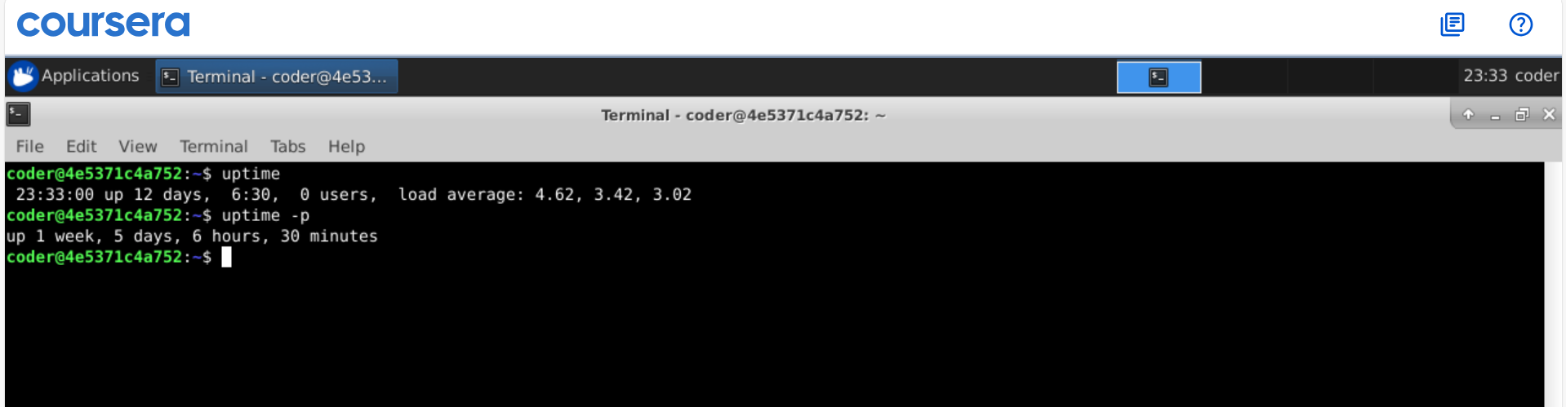
Explanation: Using uptime command we can see the uptime of the system. Also if use option -p it will give the output in weeks, days and further.
Answer 2
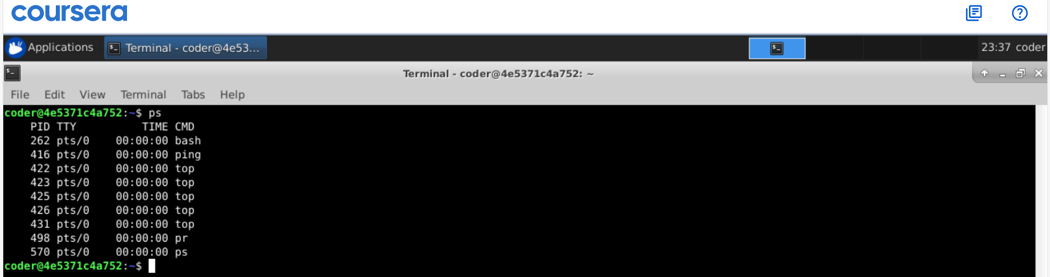
Explanation: By using the ps command from my user name I can get the all the process currently running under my username.
Answer 3
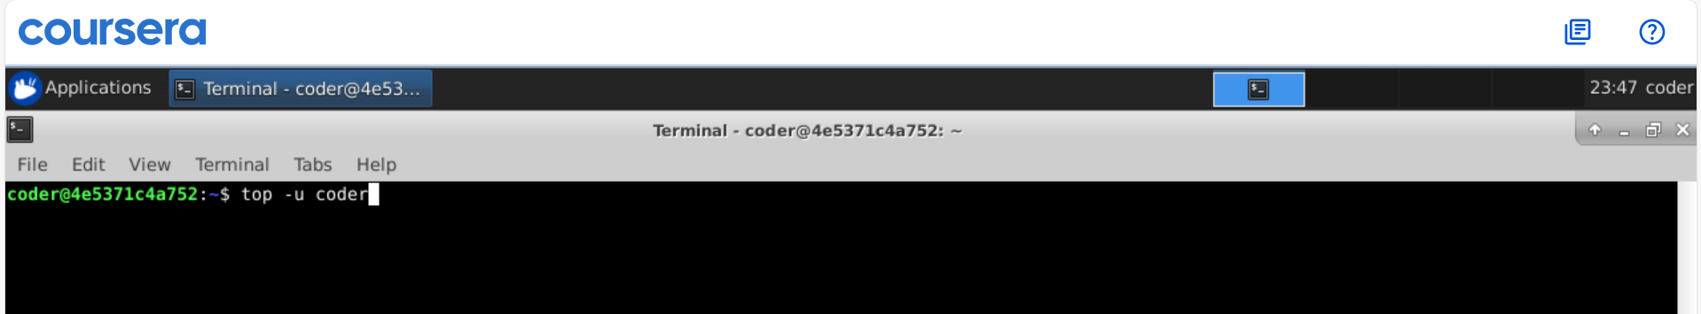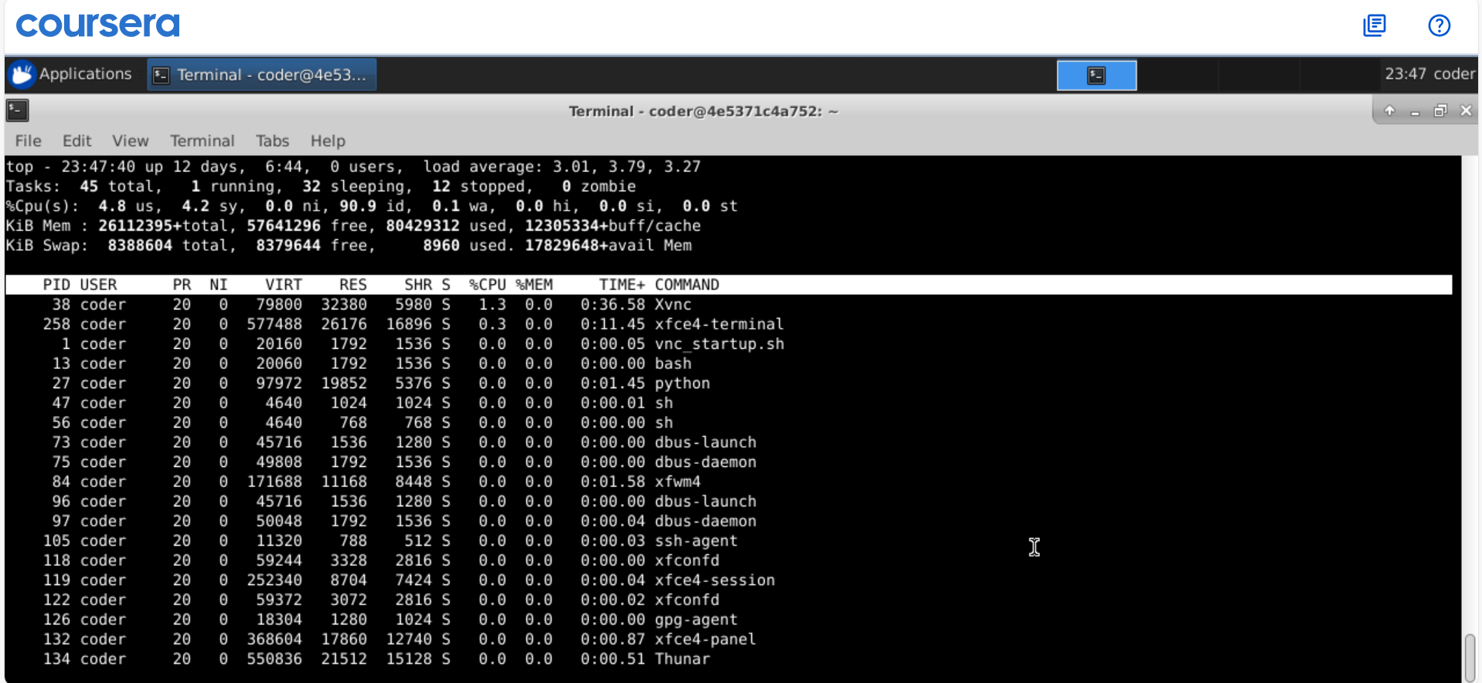
Explanation: Using top command will automatically show the CPU usage in highest to lowest. We can use -u option and specify the username to get the desired output.
Answer 4
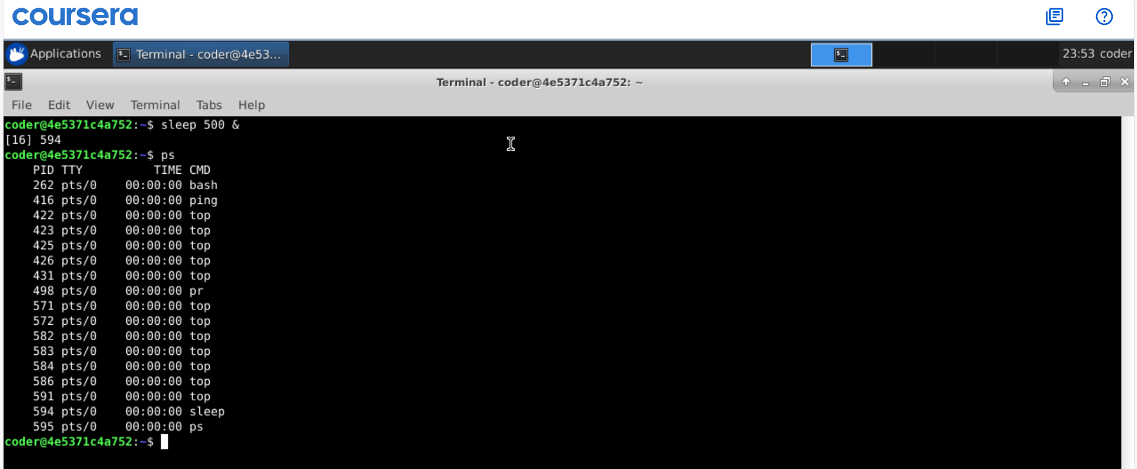
Explanation: By using & command we can run commands in the background. As shown above the command with id 594 can be seen in the ps command which show all the running processes. We can kill it using kill command followed by the PID.
Answer 5
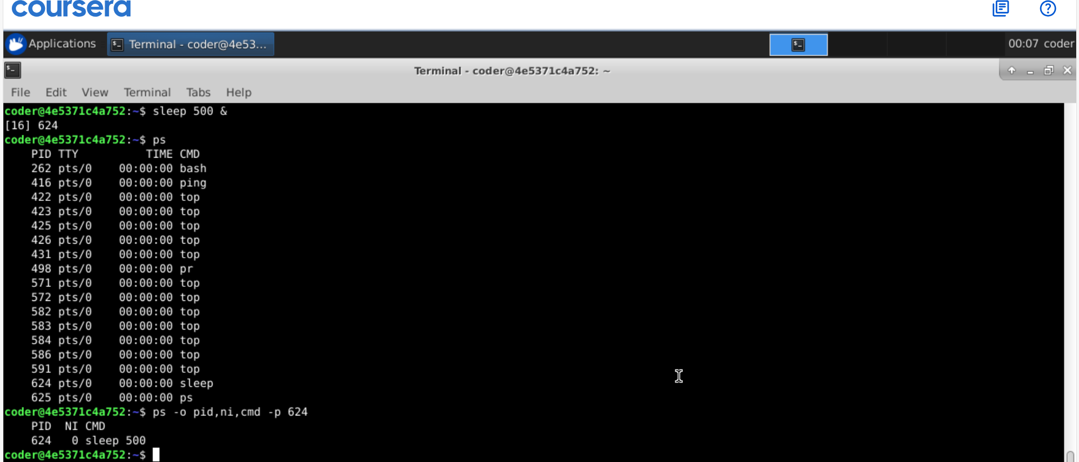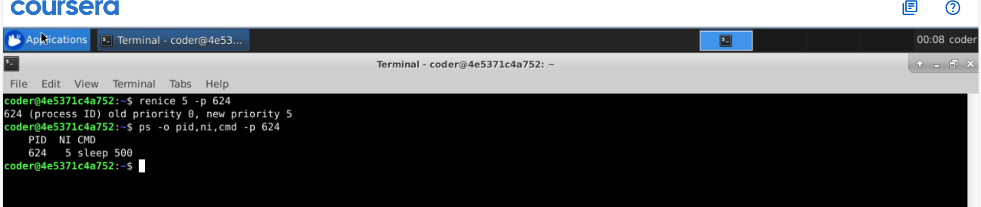
Explanation: using ps command followed by priority number followed by option -p followed by the PID will change the priority of the process. We can check using ps -o for desired format for the output followed by option p and PID.
Answer 6
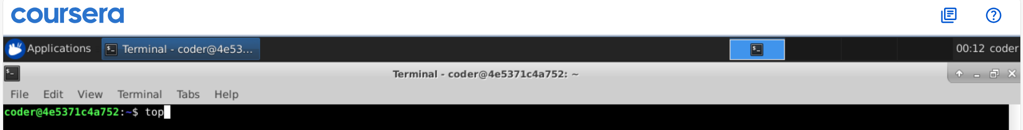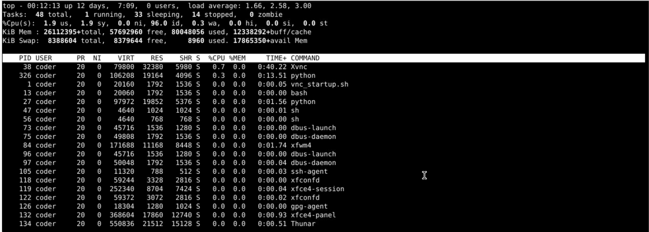
Explanation: There are different ways t check for memory usage, here I am using top command gives the detailed view. In line 4 KiB Mem is the current memory usage. Also top is already in human readable format.
Answer 7
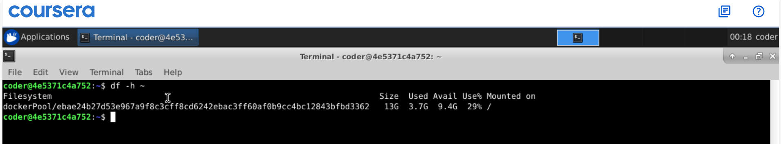
Explanation: disk space usage can be checked with df command and using -h option we can get human readable size. We use ~ for home directory.
Answer 8
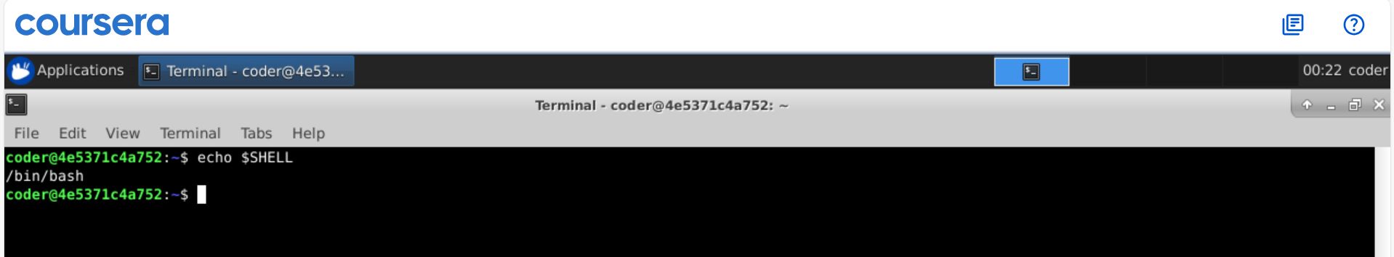
Explanation: $SHELL will give the name of shell in use and echo will show it on the screen.
Answer 9
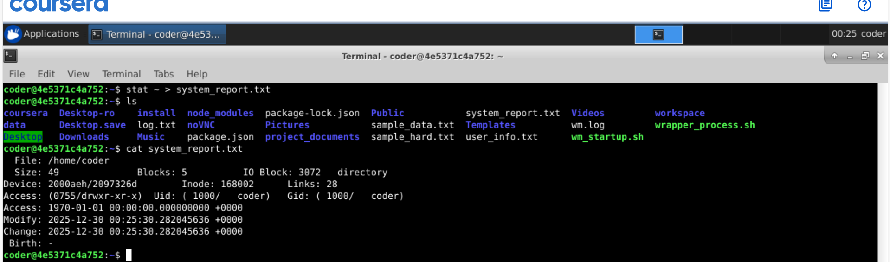
Explanation: using > we can send standard output to a file. In above, I used stat command on home directory and send the output to system_report.txt. >> this will append the file.

Answer 10
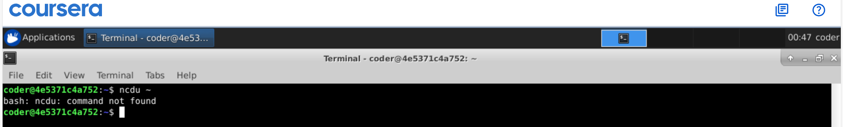
Explanation: we don’t have permission for ncdu command. But it’s a interactive tool used to navigate through directory and files. We can delete files and do more just with different options.
Nandita mam explained it in class I will attach the screenshot from the class which will show hoe the interactive tool look like.
